Parkland Village Membership Handbook
Welcome to Parkland Village! We are a non-profit New Mexico organization with 501(c)(3) tax-exempt status. We are also a community of neighbors helping each other with our daily tasks. Our goal is to help neighbors age in place. We will help you stay in your home and neighborhood and be an active member of this community for as long as possible. Secondarily, we aim to strengthen a sense of community in our neighborhoods through events designed to help us get to know and appreciate each other. Toward these goals we provide services primarily by people who live in the neighborhood. In that sense, we are neighbors helping neighbors. The neighbors we are helping are seniors and people with disabilities. They are the people for whom aging in place is most immediately crucial.
All our volunteers have gone through our orientation and have been vetted by Sterling Volunteers, a non-profit organization that provides criminal background checks for volunteers and driving-record checks for volunteers who plan to provide transportation.
Everyone who receives services must be a member of Parkland Village (PV). Volunteers are not required to also be members unless they plan to receive services themselves. However, volunteers will be encouraged to become members. Many members will both receive and provide services.
Membership Dues
Individual membership: $150 per year (equivalent to $12.50 per month)
Household membership: $200 per year (equivalent to $16.67 per month)
For low-income neighbors who cannot afford the regular dues, we can offer discounted dues. Please call us at 505-417-8799, and we will discuss what you can afford. No one will be refused services because they lack the funds to pay membership dues.
We ask members for a year’s commitment, but individuals can request to pay in installments if they are unable to pay the entire annual dues at once.
We encourage you not to think of the membership dues as only paying for services. Rather, your membership will help ensure a healthy, vibrant
organization and a healthy, vibrant neighborhood. Membership dues help pay for insurance, the platform that includes our website, development of the website, telephone expenses, accounting software, Zoom, mailing expenses, office supplies, Village literature, events, and more.
In the event of relocation from our service area, dissatisfaction with PV services, or the death of a member, the member, agent with power of attorney, or personal representative may receive a prorated refund of the membership fee dues minus an administrative fee (currently set at $20). This refund will be provided upon written request.
Service Area
The area that includes people who are eligible to be members is shown in the map below. Upon request, we can accept as members people who live reasonably close to the boundaries of our service area. Contact us if you wish to become a member and you live within several blocks of our boundary.
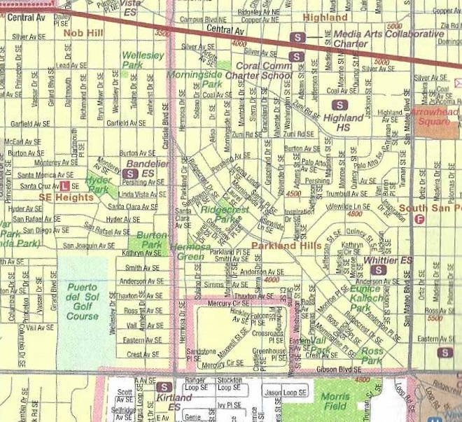

Becoming a Member
A member must be physically and mentally able to live in his or her home. To become a member of Parkland Village, find the membership registration form on our website (www.parklandvillageabq.org) or e-mail or call us, and we can mail a form to you. The brief form asks for your contact information and other details to help us serve your individual needs. All of your information will be kept confidential and accessible only by our data administrators and relevant volunteers.
If you indicated that you anticipate needing services relatively soon, someone from the Membership Services Committee will arrange with you to conduct a new member assessment at your home. Part of that assessment can be done via Zoom, if you have that capability. We’ll be asking about the composition of your household, pets you may have (some volunteers are allergic to some kinds of pets), whether anyone in the home smokes (that could limit which volunteers serve you), how well you can do things on your own, and other pertinent questions. You will be asked to sign a membership service agreement. You will be provided with various Village policies. If you own your home, to be eligible to receive services at your home, we ask that you provide proof of homeowner’s insurance. While the pandemic is still causing concerns, we will have a separate COVID-19 policy in force.
Our village community serves all elders and persons with disabilities who reside in our service area regardless of gender, gender identity, sexual and affectional orientation, race, ethnicity, national origin, creed, marital status, veteran status, immigration status, religion or political affiliation.
Services
PV is not a substitute for emergency services or any kind of health care or care provided by a professional. PV does not provide the level of services that would be available in an assisted living facility. Rather, trained and vetted volunteers are available to help with ordinary chores related to daily living.
Volunteers offer services by accepting requests from members. Therefore, the earlier requests are made, the more likely we can match the member with a volunteer. The more notice that a member gives in advance of the day they need the service, the more likely it is that a volunteer will be available.
Generally, volunteers will commit to up to two hours of support for chores in and around the home (depending on the chores requested). If a task takes more time, a member may need to make a follow-up request.
The following are services that we provide:
Transportation
Volunteer drivers will provide rides within Bernalillo County and to Rio Rancho (only medical appointments in Rio Rancho). For most daytime trips, volunteer drivers will provide door-to-door transportation and wait while you complete your business. For trips that last longer than two hours, it is possible that a different driver would drive you home. A volunteer driver can also help carry and put away packages. Members being transported must be able to transfer themselves into the vehicle (or do so with the help of a friend or family member), but the driver may be asked to fold up and/or store a cane, wheelchair or walker in the vehicle.
Typical destinations might include:
● Transportation to grocery and other stores, bank, post office, library, pharmacy
● Airport
● Doctor, dental, or other professional appointment
● A veterinarian appointment with the member’s pet
● Social or educational event in the daytime or to a Parkland Village-organized event in the evening
● A visit to another PV member
● Religious service

Friendly Visits
Volunteers can visit a member at home to provide companionship – talking, reading, playing cards or games, sharing a hobby or special interest, or taking a walk together. Visits may also take place by phone or videoconference.
A volunteer might assist with meal preparation when a member is temporarily unable to cook for herself or himself.
Chores in and Around the Home
Volunteers can provide light chores in the home and yard where a professional is not needed. Examples of light chores are:
● Replacing light bulbs
● Hanging pictures
● Putting up and taking down screens
● Moving furniture
● Simple repairs
● Changing batteries
● Taking out the garbage
● Raking leaves and simple pruning of plants
● Basic help with computers and other electronics
Assistance by Village volunteers is not meant to substitute for a regularly scheduled housekeeper, gardener, or skilled or licensed repair person (such as plumber, electrician, carpenter, etc.).
PV cannot help if:
● The member has an extreme physical or mental deterioration beyond PV’s capability of providing services
● The member has emotional or behavioral disorders which are so severe as to cause destructive behaviors toward themself or others or disruptive behavior while in the presence of volunteers
● The member has a communicable disease that puts a volunteer at risk
How to Request a Service
Please make your request for a service at least three business days prior to the day you need the service, so we have time to find a volunteer. That is especially important if you need to have the service provided at a specific time, such as a ride to an appointment.
If you use the Internet and have access to the Parkland Village website, www.parklandvillageabq.org , sign into the website with your password and click on the Members tab, and then click on New Service Request. Fill out the form and save it. You will be asked to select the time and date that you need the service and the purpose of the service. Indicate whether the time and/or date are flexible.
If you are requesting a ride, include the address of your destination. Your volunteer will contact you after accepting your request. The volunteer will provide you with their phone number. In cases where no volunteer accepts the request by 24 hours prior to the time the service is requested, a volunteer services coordinator (VSC) will contact you. You’ll be asked if you wish us to continue our search for a volunteer and for how long we should search. We hope to be able to fulfill requests within two or three days. If you need to cancel the service request, please contact the VSC at 505-417-8799 as soon as possible.
If you prefer to use the phone to make your request (or you do not use the Internet), call the Volunteer Service Coordinator at 505-417-8799. If the VSC on call does not answer the phone, leave a message, and you should receive a response by the end of the following business day. In your message, leave details about the kind of service you need and when you need it.
Members should not contact volunteers directly. All new service requests, changes to existing services, or cancellations should be made online or by contacting the VSC. You may request a particular volunteer but there is no guarantee that the volunteer will be available. If you must make a last-minute change and you can’t reach the VSC, you can then contact the volunteer directly.
If a volunteer comes to a member’s home for a scheduled service and no one answers, the following procedure will be followed:
1. The volunteer will check the premises: knock loudly on all outside doors and look through the windows. The volunteer will ring the doorbell and/or knock again.
2. The volunteer will call the member’s phone number, and if they are switched to voicemail, they will leave a message to contact the volunteer service coordinator to reschedule service.
3. The volunteer will call the VSC to report the situation. If the VSC is unavailable, they will leave a voicemail explaining the situation.
4. If the VSC is also unable to contact the member, he/she will call the member’s emergency contact phone # to inform them of the situation.
Anti-Discrimination and Anti-Harassment Policy
Any member of PV who engages in inappropriate behavior, including harassment related to race, color, gender, sexual orientation, religion, national origin, age, citizenship status, or disability shall be subject to a disciplinary procedure to be established by the Board. The disciplinary procedure can include suspension or termination of membership.
Termination of Membership
Termination of a member occurs when a member moves out of the service area, chooses to end the membership for any reason, fails to pay dues beyond a reasonable grace period, moves into assisted living or a nursing home, contracts a chronic, communicable disease, or dies. In addition, a member may be terminated by PV if the member does not comply with PV policies, repeatedly cancels services, or exhibits disruptive behavior that creates an unsafe or hostile environment.

Privacy and Confidentiality
We do not plan to ask for specific health information, such as diagnosed medical conditions. Member records will be maintained in a way to keep them secure, accurate, and confidential. The information we plan to collect is about members’ interests, their physical limitations, and what they need to continue living independently in their homes. Only the database administrators will have access to member records that include the member’s personal information. No records will be provided to any other person without the express prior written consent of the member. Volunteers are responsible for maintaining the confidentiality or privileged information to which they are exposed while serving as volunteers, helping out at PV events, and or talking with one another. Members also will not share such information about other members without their consent.

